
Music
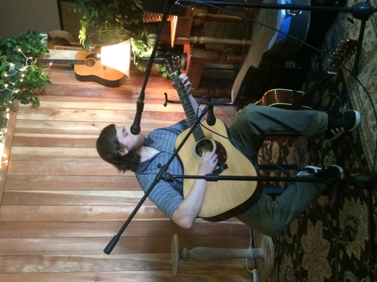
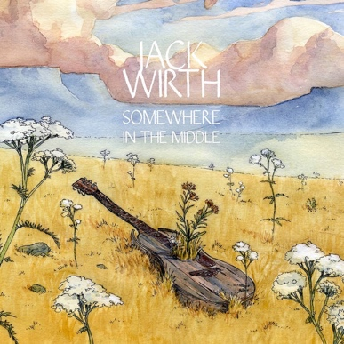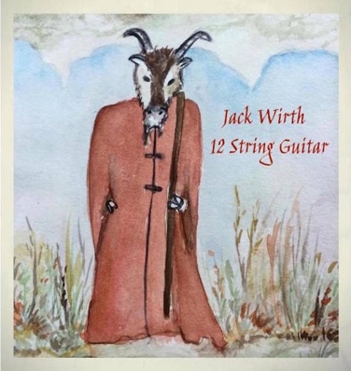
After Goodbye
The Uncharted

Bio
Jack got his first guitar at the age of 14. Before ever learning songs or chords Jack started composing and he has been enthralled by it ever since. After becoming immersed and enlightened to the music of 60's and 70's, it inspired Jack to take his playing to a whole new level. He currently has 5 albums on Bandcamp of all solo-guitar pieces written and produced by himself. Throughout his life he is always trying to take his playing to different levels and is always trying to evolve as a musician.

Links
https://jackwirth.bandcamp.com/
https://jwirth78.wixsite.com/website

Press
Appeared on radio show “Sideways through Sound” multiple times
http://2ser.selectfield.co/episodes/sideways-through-sound-800pm-31st-jan-2018/
Random album review
https://rateyourmusic.com/list/Tintamarre_Wazoo/a-tale-of-2016/3/
Album review from “Dying for Bad Music”
https://dyingforbadmusic.com/blog/post/2016/07/jack-wirth-2016-jack-wirths-album.html

Contact Details
Email: Jack6329373@gmail.com
Phone Number: 5306329373

