Jack Wirth

Prepared by: Jack Wirth
NAME and Student #0810609
DATE: 12/2/18
PM340-xxx

TABLE OF CONTENTS

EXECUTIVESUMMARY……..……………………………………………………………….........3
FOUNDATIONS OF YOUR BUSINESS………………………………...........................................4
Description of Business…………………………………………………................................4
History/How the Business got Started......................................................................................4
Company Vision/Mission Statement……………………………………………....................4
Social Entrepreneurship…………………………………………………………………........4
Business Profile: Goals and Objectives…………………………………………………........4
Business Profile: Key People in Your Organization…………………………........................4
Business Profile: Form of Business Ownership (legal structure) …….……….......................4
DEFINITION OF THE MARKET/DESCRIPTION OF PRODUCTS & SERVICES….………..….5
General and Target Market……………………………………..…………………………….5
Detailed Product/Service Description……………………………………...………................5
Product Comparison……………...…………………….………………………………..…...5
MANAGEMENT AND ORGANIZATIONAL STRUCTURE …………..………………………...6
Management……………………………………………………………....…………………6
Leadership Philosophy…………………………………………………….….……………...6
Organization Chart…………………………………………………………...........................6
Customer Service Policies………………………………………………………….…………6

MARKETING AND SALES………………………………………………………………………...7
Marketing Mix…………………………………………………………......……...................7
Pricing Philosophy…………………………………………………………………………...7
Sales and Distribution…………………………………………………………......................7
Strategic Alliances…………………………………………………………………...............7
FINANCIAL INFORMATION……………………………………………………….......................8
Start up Expenses…………………………………………………………………….………9
Cash Flow Statement……………………………………………………………………......10
Income Statement…………………………………………………………………...……....11
CONCLUSION ……………………………………………………….............................................12
BIBLIOGRAPHY …………………………………………………….............................................13

EXECUTIVE SUMMARY

Jack Wirth is an artist and an innovator. Located in California, he strives to leave his print on the world and to plant a musical seed through audible vibrations. Due to his “do it yourself” mentality he is on a mission to become a leading voice in music publishing and to compose and place music for TV & Film. Through his music he portrays life, death, sadness, and happiness. Sounds that will be able to put you in a trance, deep into thought, make you forget and make you remember. As the sole proprietor of his company he plans on marketing towards fans of American Roots music and Jazz. With aspirations of composing for Tv and Film, another prospect of his will be music supervisors and producers.

FOUNDATIONS

Description
Jack Wirth composes, performs and publishes music written by himself.

History
Since he has been playing guitar, he has been composing music. He got the idea to start his own publishing company when he found out that if he owns the publishing rights for his music, it is easier to sell the rights to music supervisors with the intent of placing it for tv/movies.

Mission
His mission is to leave a musical mark on the universe through multiple platforms such as the internet, movies/Tv and live performance. He is on a mission to squeeze something out of the guitar that has never been done before and influence those after him.

Social Entrepreneurship
It is a goal of Jack Wirth’s to show emotion through his music. He wants to evoke feelings of tranquility, anxiety, life and death. He hopes to help with social movements such as mental health awareness.

Business Profile
A goal within the first year is to play at least one gig a week. He will achieve this by pushing himself and by finding inspiration.

Another goal is to sell music online and to one day produce physical CD or Vinyl.

Another goal is to upload music to a SYNC library and to make contacts with music supervisors.

Business organization
Jack Wirth will do most of the work in this business unless he chooses to record his music at a studio or needs someone to do artwork.

Business Profile
This will be a sole proprietorship and Jack Wirth will do all the work for this business unless he decides otherwise. “The sole proprietorship is the simplest business form under which one can operate a business. The sole proprietorship is not a legal entity. It simply refers to a person who owns the business and is personally responsible for its debts”

General and Target market research

The overall market and industry that Jack Wirth will be in is music publishing. Currently this business is in the early stages. As long as there are buyable forms of music, music publishing is relevant. Customers I would like to sell to are fans of Jack Wirth’s music and Music supervisors. Music and Video will always have a relationship with each other so there will always be a market as long as music supervisors are working.
Currently in the music publishing the “Consent Decree” is being reviewed by the Department of Justice.
“As it stands now, it’s an all or nothing relationship between a PRO and songwriter or publisher, meaning if a composition has been registered with the PRO then that composition cannot be licensed to a third party directly. Songwriters and publishers are banned from withdrawing portions of their rights – and therein lies the rub!” (Eggerton 2018)
“The consensus is to amend them. It appears changes to the Consent Decrees are on their way and given the comments from this panel, those changes will mostly address the music streaming services.” (Eggerton 2018)
Jack Wirth’s top 3 products are Composition services, Jack Wirth’s Original Music in Digital format, and Performance. I will get the product to the customer through digital files such as WAV or MP3. I will advertise through social media such as Instagram and slowly try to build my resume of work in this field.
Comparing Jack Wirth to other music publishing companies is hard because Jack Wirth is the only artist in his publishing company. For this company it is only meant to publish/sell/promote Jack Wirth’s compositions. A company like “Kobalt” is one of the biggest in the game, with a roster of many artists. I would imagine that with dealing with businesses like this it’s hard to get in touch with the artist and you would have to deal with Kobalt. With Jack Wirth if you needed something to be done you would talk to him personally. Another large competitor is “Downtown music publishing”. Jack will try to make his website similar to theirs because he likes how it has a simple approach.

Management and Organization Structure

Management and Organizational Structure

- These “employees” require little to no management.
- Sole Proprietorship
- Lawyer and Graphic Designer will be paid by project. Accountant and Booking agent will be paid accordingly.
- I do not provide Health Insurance
- Most of the people I hire will work freelance.

Jack Wirth is his own boss and to succeed with this he will need to manage his time and money well. As for others he will need to stay in contact with his booking agent and if needed an accountant. The other employees will be paid per project.

He will work from home with the goal of eventually moving to a studio.

Equipment
Macbook | Fresh Tape
Studio Monitors | Guitar Pedals
Tascam 58 | Studio Quality microphones

His main goal is to be able to support himself solely through music. Within the next 3 years he would like to have my music published. A long-term goal is to have music placed in TV or Film within the next 10 years. He would also like to start playing out and gigging regularly.

His Customer Service policy is that he will get back to everyone who has any inquiries and to do his best to achieve customer satisfaction.

Marketing
Jack Wirth plans on marketing through YouTube, Instagram and relationship building. He will use YouTube by putting out good content that is true to himself. Content that includes videos of him playing his music, nothing cheesy or phony. He will post videos and pictures on Instagram promoting projects/events that he is currently working on. He will hit the local music scenes of Boston and Northern Ca to meet local musicians and friendly people. He hopes to attract creative minds, and music lovers. He also hopes to catch the ear of someone who is interested in placing his music in TV or Film i.e. Music Supervisor. Time management is very important to Jack so he will try to incorporate self-promotion into his schedule AT LEAST once a week.

A musician like Ry Cooder is a prime example of what Jack wants to do. Ry Cooder is not only an amazing musician but also is a force in the world of movie soundtracks and music production.
Another example is Daniel Lanois, a musician and producer who has had songs on movies such as “Friday Night Lights” and more recently contributed to the Red Dead Redemption 2 soundtrack.
Another Musician Jack admires is Blake Mills, he is prominent in the LA music scene and known for his guitar skills, composing and producing.
While they aren’t the biggest names ever, all of the musicians have outstanding accolades and seem to dabble in a little bit of everything when it comes to the music industry.

financial information

To get the best out of Jack Wirth he will eventually need his own space for a personal studio to compose and record music. He makes his income from performing, selling music and composing music that can be paired with the transmission of moving pictures. Throughout life obtaining gear will be a constant such as instruments, amplifiers, and microphones. For year one of this business Jack will be in Sacramento area performing and composing. He will also have income from a part-time job to fund his rent and other important costs. For year 2 he will move to LA, which will bring him more opportunity for performing. Although the rent is higher, La is also the biggest hub for TV/Film, so this will bring the opportunity of meeting more people in that industry and more of an opportunity to get music placed in tv or film
Start Up Costs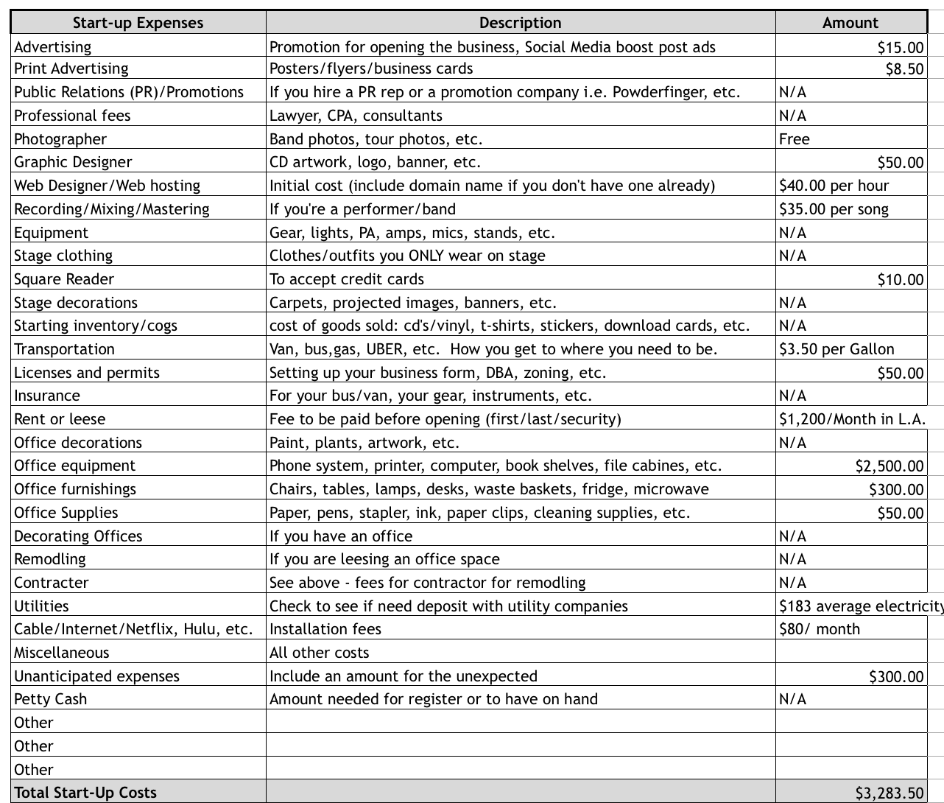

12 Month Cash Flow Statement: Year 1 2020
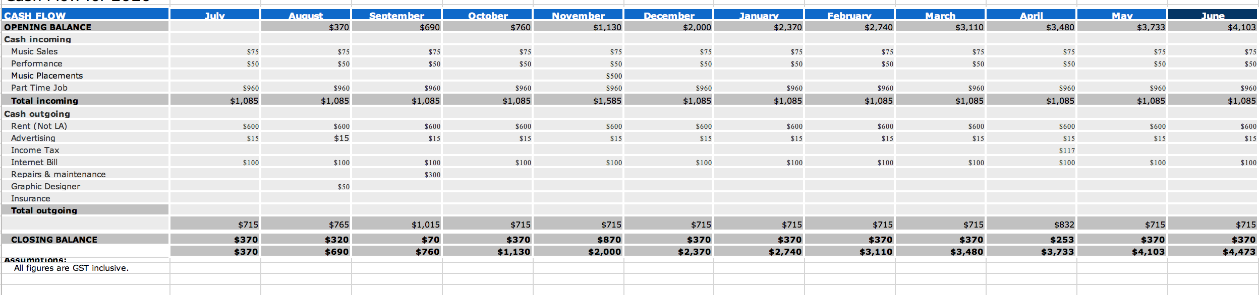

12 Month Cash Flow Statement: Year 2_2021
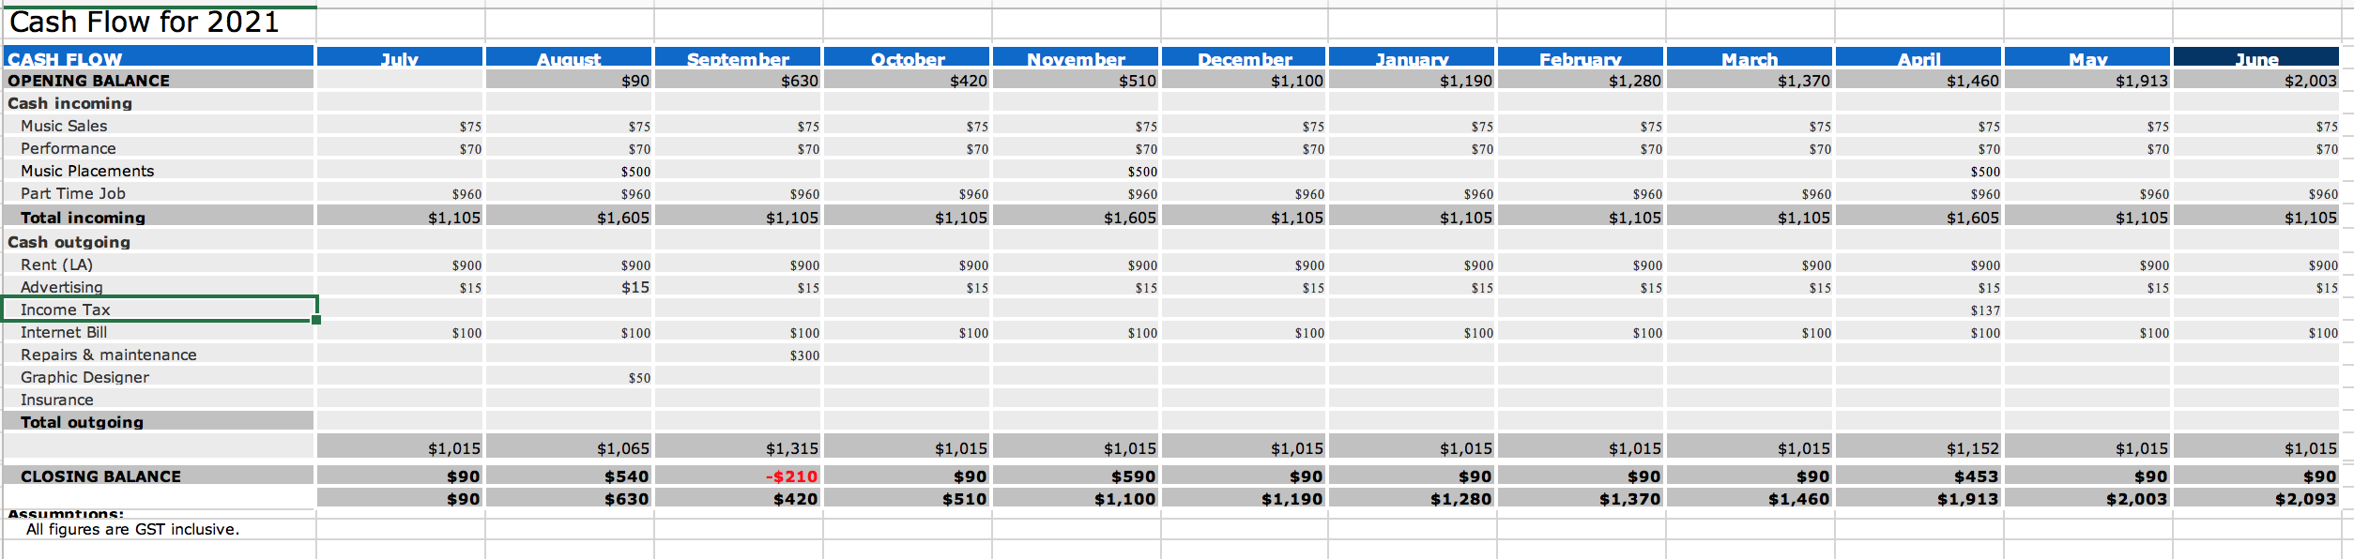
Income Statement

Jack Wirth

Year 1
Total Income $13,520

Income Taxes -$117

Operating Expense -$9047

Net profit
After taxes and Operating Expenses $4,356

Year 2

Total Income $14,760

Income Taxes -$137

Operating Expense -$12667

Net profit
After taxes and Operating Expenses $2,093



CONCLUSION

In conclusion, Jack Wirth is striving to leave his musical print in the world through his compositions. He is finding a niche for his unique sound in the world, and is working his way up by consistently recording, composing and performing. Through originality and perseverance, he is on his way to becoming a leading force in the music industry.

Thank you for your time and Happy Holidays!

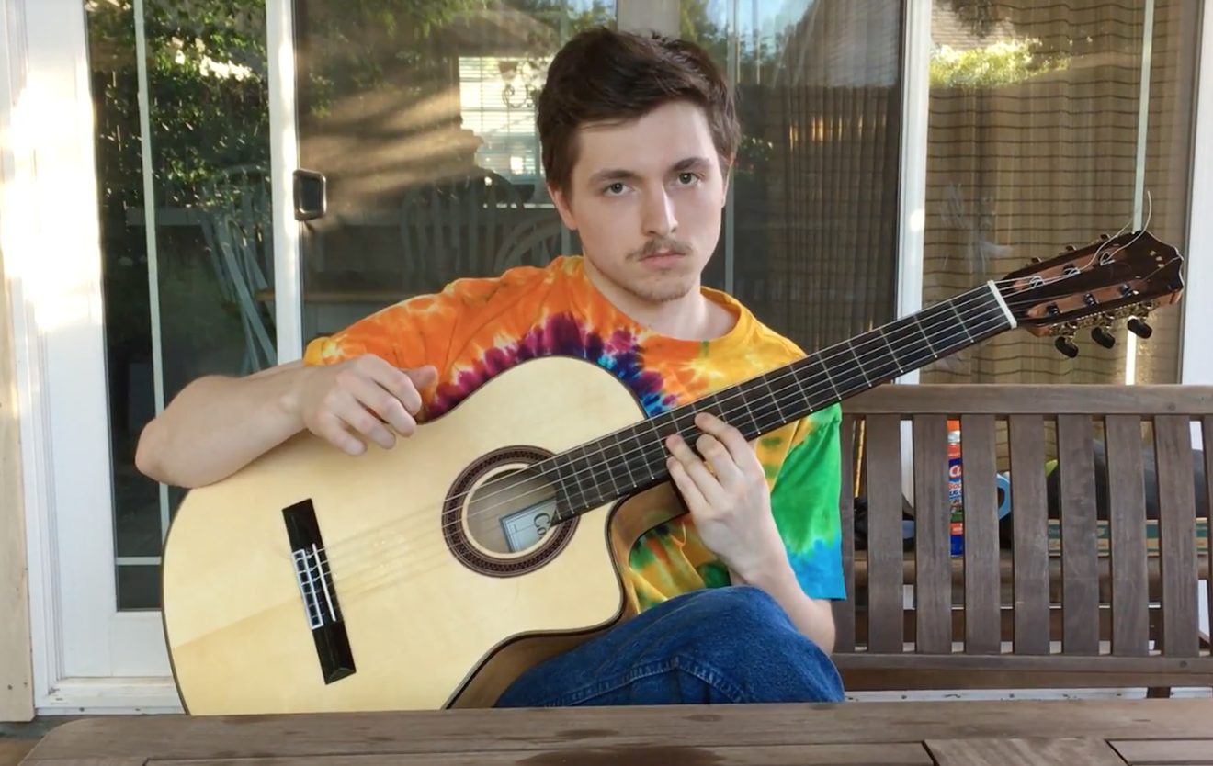

BIBLIOGRAPHY

- Eggerton, John. “DOJ Antitrust Chief: We Are Reviewing ASCAP, BMI Consent Decrees.” Broadcasting & Cable, 28 Mar. 2018, www.broadcastingcable.com/news/doj-antitrust-chief-reviewing-ascap-bmi-consent-decrees.

- https://www.dmpgroup.com/

- https://www.kobaltmusic.com/
- http://www.earthtonesacramento.com/

- https://www.entrepreneur.com/encyclopedia/sole-proprietorship

- https://www.blakemillsonline.com/

- http://rycooder.com

- https://www.daniellanois.com/

https://www.entrepreneur.com/encyclopedia/sole-proprietorship
http://rycooder.com https://www.daniellanois.com/ https://www.blakemillsonline.com/
: Square Reader https://www.amazon.com/Square-Reader-Magstripe-Lightning-Connector/dp/B07J1NL16J/ref=sr_1_1?s=office-products&ie=UTF8&qid=1544241969&sr=1-1&keywords=square+reader Recording Studio in Sacramento http://www.earthtonesacramento.com/

